Volunteer Handbook

Welcome

Welcome to the Harris. We are delighted that you have joined us as a volunteer and we hope that you find your time here both enjoyable and rewarding.

The purpose of this handbook is to introduce you to the Harris, its structure, and your role within the organisation. If you have anything that you are unsure of, concerned about or would like to suggest, then please let us know. We are here to support you.

The contents of this handbook:

Mission Statement
Opening Hours and useful contact details
The Harris: An Introduction
Staff structure
Expenses and Benefits
Facilities and procedures
Resolving issues
Volunteering and benefits
Volunteering: what can you expect?

Mission Statement

The Harris welcomes and inspires visitors from Preston, the region and beyond.

We are proud guardians of our founders’ intention that; ‘The mental riches you may here acquire will abide with you always.’

We continue to enrich the lives of our audiences by creating links between people, collections and exhibitions, by celebrating creativity and stimulating learning.

Vision

To extend our reputation as an outstanding museum and art gallery that is distinctive, ambitious, audience-focused and open to change.

Values

We strive to work to the highest professional and ethical standards.

We value the knowledge, skills and diversity of our staff and are determined to create a workplace where all colleagues can reach their full potential.

We believe that a fulfilling work environment where individual and collective contribution is acknowledged and valued, communicates itself positively to visitors.

We research and identify the needs of our audiences and seek to meet and exceed their expectations, thereby driving the Harris forward as a premier cultural organisation.

We are accountable for our decisions and for the stewardship and development of our resources, for the benefit of current and future generations.

Our current opening hours are:
Monday: 9am - 5pm (Galleries open at 11am)
Tuesday: 9am – 5pm (Galleries open at 10am)
Wednesday: 9am – 8pm (Galleries open at 10am)
Thursday: 9am – 5pm (Galleries open at 10am)
Friday: 9am – 5pm (Galleries open at 10am)
Saturday: 9am – 5pm (Galleries open at 10am)
Sunday: 11am – 4pm

Postal Address:
The Harris Museum, Art Gallery and Library,
Market Square
Preston
Lancashire
PR1 2PP
Tel: 01772 258248 (Mon – Fri: 9.00am – 5.00pm)

Other useful information:
Shop: 01772 905414
Office: 01772 258248
Programmes Manager - Sue Latimer: 01772 905403 s.latimer@preston.gov.uk

The Harris: An Introduction

Permanent Collections
The Harris’ collections include:

Fine Art: This collection features oil paintings, watercolours, prints, drawings, sculpture, photography, film and books. Predominantly British Art dating from the 12th century to the present day. The Harris’ most recent acquisition of contemporary art in 2016 was a full length film by artist Nathaniel Mellors.

Decorative Art: This collection features ceramics ranging from 17th century slip-ware to studio pottery from the mid-20th century. It also features glass enamels, Preston Guild memorabilia and other special objects including the largest scent bottle collection in Britain - one of the most important collection in the world.

Costume and Textiles: This collection features women’s, men’s and children’s dress and accessories from the 18th century through to the present day. It includes Preston Guild related dress, farm workers’ clothing, traditional Asian dress, fashion plates, embroidery, quilts and other beautiful items such as an 18 volume set of historic South Asian pattern samples.

Social History: This collection features social history objects related to Preston’s industrial development and local business, its community and its traditions. The collection includes archaeology, ethnography, coins and medals, greetings cards, trade and cigarette cards, stamps, local history, music sheets and Preston Guild souvenirs.

Exhibitions
The Harris is proud to be one of the region's liveliest exhibition venues, with temporary exhibitions of local, regional, national and international relevance and importance. Our well established Contemporary Art programme has a national reputation. We develop and curate our own exhibitions and also receive ready - made touring exhibitions from other venues. We have four curators that manage the collections and exhibitions and who work closely with learning and access staff to ensure that our visitors are given creative and interesting “ways in” to enjoying the Harris. “Ways in” could include: talks, debates and tours; practical workshops; behind the scenes exploration; projects (short term and longer term); art work/objects in focus; handling the collection; guest speakers and of course volunteer opportunities.

Learning
Learning and Access staff help to create and deliver a range of regular activities and events based on our exhibitions and collections that aim to engage not only with our everyday visitors but with specific target audiences with the aim of diversifying our visitor profile. These target audiences include: families, schools, colleges, community groups, young people and older people and minority groups. We often contract professional freelance artists to help us to deliver this work and this takes place both at the Harris and through outreach in the community, for example, reminiscence sessions held in local rest homes. Harris volunteers play a really important role in delivering these activities and events and helping to encourage inclusion.

Marketing and developing our audiences
We have our own corporate identity and all our design and publicity is created in house by our Audience Development Officer and Designer at the Harris. For each new exhibition, we provide written information and interpretation for visitors along with a regular “What’s on” guide which is designed and printed every 6 months. Our website is also updated in house and we use social media to help to spread the word far and wide. We use Facebook, Twitter and Instagram and also have a blog which is hosted by the “Friends of the Harris”.

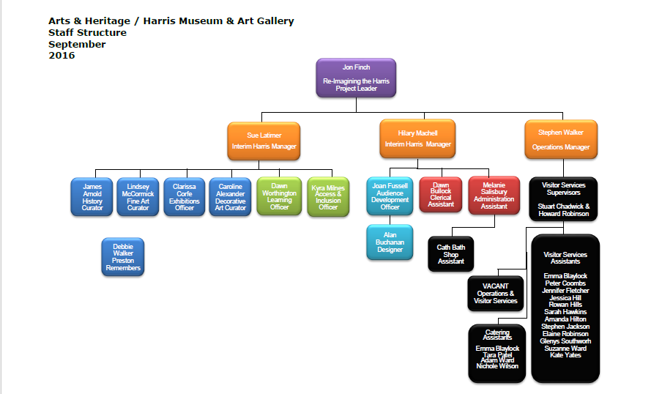
Staff structure as of September 2016

Staffroom and quiet areas
You are welcome to use the Harris staffroom. It is in the basement of the building and is shared by the 3 teams (Museum, Front of House, Library). You will need to ask a member of staff for access into the basement as not everyone has keys. You can make a drink quickly and without going all the way into the basement by using the old museum staff room which is upstairs from the Museum Office. Tea and coffee is provided and you will have full use of all of the facilities in the kitchen area.

Toilets
Men’s toilets are on the stairs between the first and the second floor. Ladies toilets are on the first floor. There is an accessible toilet on the ground floor in the annexe (next to the education room). The key for this is kept behind the Harris shop. There are also a couple of toilets within the Education Room which are available for your use however they do tend to be used mainly by school groups that visit us.

Fire procedure
You will receive a fire safety tour of the building. This will take place during your induction period and will give you an overview of what to do in an emergency to give you confidence and knowledge in an emergency situation.

Signing in and recording hours
All volunteers need to sign in when they enter and leave the building each time they arrive for volunteering. There are two signing in books which are located in the reception area in the Museum Office on the first floor. Please insert your name and timings into both books each time you enter and exit the building. One book is to ensure safety in the event of an emergency and the other is to monitor time accumulated through volunteer activity. This calculation is invaluable as it helps us to acknowledge your dedication to making a difference at the Harris to funders and stakeholders.

Commitment
We will be as flexible as possible to accommodate you and your individual needs whilst aiming to provide you with a unique quality experience during your time spent at the Harris. We really appreciate our volunteers being honest and reliable and exercising a degree of responsibility. For example, giving us as much notice as possible if you are unable to volunteer helps us to plan for a positive visitor experience.

Communication with public and media
We do not expect you to act in an official capacity and speak for the Harris and/or Preston City Council in any manner (formal or informal) unless previously arranged with supervisors as part of your volunteer role. Volunteers are advised not to make any comment if asked for an opinion by press or other media sources. Similarly, volunteers should not produce any marketing or resources without seeking guidance from staff first. All media enquiries should be directed to marketing staff. This is not to stop volunteers from acting as positive advocates and ambassadors for the Harris but to recognise the Harris’ responsibility to maintain standards and control over its media profile.

Dress Code
There is no specific dress code at the Harris for volunteers. Smart casual is the general rule but to be clean and tidy is more important. All volunteers working in a public facing role will be issued with a volunteer badge that they will be required to wear at all times. We do have Harris branded t-shirts and hoodies that are available if you prefer to wear one of these and be easily identified as part of the team.

Customer Care
Visitor satisfaction is a priority at the Harris. Visitors will often make no distinction between volunteers and paid staff. You should aim to treat all visitors equally and fairly, using empathy and compassion and without judgement. If in any doubt, please seek the support and guidance of a member of staff as quickly as possible – we are always here to help.

Expenses
It is acknowledged that the essence of volunteering is the giving freely of one’s services and while volunteers may not expect any form of financial reward for their services, they should not expect to be out of pocket as a result. Volunteers will be reimbursed for reasonable out of pocket travel expenses (eg. the most economical transport possible between home and the site) on production of receipts or tickets. Please have a chat with us in advance of travel if you think you might need to be reimbursed.

Meal expenses will be provided for volunteers who volunteer for four hours a day when that time bridges lunch time. This will consist of a voucher for the equivalent of a sandwich and a hot drink in the Harris café. A member of staff will give you one of these.

Travel expenses forms can be found on the Volunteer Information Board in the office entrance. When completing an expenses form, please state the reason for the expense (e.g. visiting nursing home for reminiscence work) and remember to write the date on the form. Please attach all receipts to the form. Take the completed expenses forms to your supervisor or a manager as they need to sign the form in order for your money to be reimbursed.

Supervision and Support
It is your supervisor’s role is to act as a primary contact for you. If you have any problems or just need a chat in general, please see them in the first instance.

Induction and Training
All new volunteers must have an induction to the Harris which will include a fire tour of the building. Your supervisor will show you where toilets, staff rooms and other facilities are located and you will be introduced to other members of staff as you go along. You will receive specific training relevant to your volunteering role. This training is dependent on your own personal needs and will be discussed at your induction.

Regular Meetings
Regular meetings are held to enable information sharing and updates and also for you to express any suggestions to improve the volunteer programme or any concerns you may have that are relevant to volunteering at the Harris. Other volunteer events such as social gatherings take place throughout the year to give you the opportunity to socialise, network and meet other like-minded volunteers and staff. These events often provide Harris staff the opportunity to formally recognise your valuable contribution to the Harris.

Moving On
You will be invited to complete an informal exit interview if you wish to end your volunteering role at the Harris. This process of evaluation is for the future benefit of other volunteers to improve the quality of the services we provide and our procedures. We really value your feedback.

Resolving Problems

- In a situation where you have a grievance, you should discuss this initially with your supervisor in confidence, who will try to resolve the problem as quickly as possible for you.

- If your supervisor is unable to resolve the matter, then it will be referred to a member of the senior management team for resolution.

- If you feel unable to discuss the issue with your supervisor (or if he or she is absent) then you should contact a member of the senior management team who will investigate the problem for you in confidence.

- By signing the Volunteer Agreement, you are agreeing to adhere to the standards of work performance and behaviour set by Preston City Council. In the event that your conduct is deemed to fall short of these standards in any way, your supervisor will in the first instance, discuss this with you privately and confidentially.

- If conduct does not subsequently improve to the required standard within the agreed timescale, this will be discussed further with a view to ending the Volunteer contract. In the case of serious misconduct, the Harris reserves the right to end the Volunteer contract with immediate effect

Volunteering and your benefits
You can volunteer and claim benefits if:
- the only money you get from volunteering is to cover expenses, like travel costs
- you continue to meet the conditions of the benefit you get
It is your responsibility to inform your benefits advisor of changing in your situation due to volunteering. The Harris/Preston City Council will not accept any responsibility for this. If you are unsure about any aspect of the benefit rules or you have any problems with your benefits advisor, please speak to your supervisor who will help you to find the information that you need.

For more information, go to:
https://www.gov.uk/volunteering/when-you-can-volunteer

Volunteering : what can you expect?

☺ To feel valued

☺ To have a sense of purpose

☺ To connect with others

☺ To gain up to date experience to help you gain employment

☺ To meet different types of people

☺ To try something different

☺ To make new and lasting friends

☺ To share your experiences with others

☺ To use your experience and talents to help others

☺ To learn new skills with training provided

☺ To give something back

☺ To make a difference

☺ To have a sense of personal achievement

☺ To have the satisfaction of making things happen

☺ To be part of a team and feel like you belong

☺ To improve your sense of wellbeing

Welcome aboard!

